Worksheet – Underlying Trends

# Describing Trends

Trend means – look at the data and describe what is happening. This is done in two steps:

1. Look at the data/graph as a whole

* Think: linear regression techniques:
  + Line of best fit / regression line (whether calculator or “eye-ball”)
  + Correlation co-efficient *r*
* Describe:
  + Strength: strong, moderate, weak
  + Direction: increasing, decreasing, steady

2. Look at the Connections in the Line Graph and describe either:

* Regular fluctuations OR Seasonal – there is a repeating pattern WITH a regular frequency of occurrence / a constant time period, e.g. seasons or same number of months or same number of days
  + Identify the length of 1 season. NB: 1 season = one cycle, that is where the pattern begins to repeat
* Irregular fluctuations – there is a repeating pattern without a regular frequency of occurrence / constant time period

# Situation

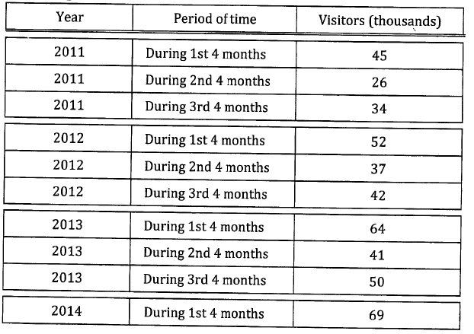During 2014 the owners of a particular tourist attraction decide to use the data regarding the number of visitors the centre has had in recent years to identify trends to indicate likely visitor figures for the future. The owners have access to the four monthly visitor totals for 2011, 2012 and 2013 and also for the first four months of 2014. These figures are shown in the table below and displayed in the scatterplot.

## Questions

1. In the table above, what does “During 1st 4 months,” “During 2nd 4 months,” and “During 3rd 4 months” mean?
2. A scatterplot for the data above is shown above:
   * Complete the graph by adding: heading and label axes.
   * Explain the trend.
3. Turn your scatterplot into a line graph and explain any underlying trends. To do this:
   * Does the graph have regular or irregular fluctuations, that is: is it seasonal in nature or not?
   * How many seasons make up one cycle?
   * When do the peaks of every season occur?
4. Predict the number of visitors and comment on the reliability and validity of your prediction for the times below:
   * November 2013
   * August 2014
5. If the next figure, i.e. for the 2nd period of 4 months of 2014, turns out to be 58 this is clearly a drop from the 69 recorded for the 1st four months of 2014 but is it cause for concern?